

Software Engineering I  
 CS251

**Easily Buy, Sell, Exchange Products web-application**2014

|  |  |  |
| --- | --- | --- |
| **Name** | **ID** | **Group** |
| Ahmed Sayed Eid | 20120030 | CS_1 |
| Ahmed Mohamed Fekry | 20120062 | CS_1 |
| Sherif Mohamed Farouk | 20120207 | CS_1 |
| Mahmoud Mohamed Hadad | 20120364 | CS_1 |
| **TA:** Catherine Bedrossian  **Dr.:** Mohamed El_Ramly   |  | | --- | | Git-hub link : https://github.com/MahmoudHadad/SW-Project.git | |  |  |

Contents

Team 3

Document Purpose and Audience 4

System Models 4

System Decomposition 4

Class diagrams 5

Sequence diagrams 11

Class - Sequence Usage 11

Physical Entity-Relationship Diagram 17

System screen shoots……………………………………………………………………………………………..18

Ownership Report 20

# 

# Team

|  |  |  |  |
| --- | --- | --- | --- |
| **ID** | **Name** | **Email** | **Mobile** |
| 20120364 | Mahmoud Mohamed Hadad | [hooda_fci@yahoo.com](mailto:hooda_fci@yahoo.com) | 01117943793 |
| 20120207 | Sherif Mohamed Farouk | [sfarouk513@gmail.com](mailto:sfarouk513@gmail.com) | 01144967048 |
| 20120030 | Ahmed Sayed Eid | [medo.shahin15@gmail.com](mailto:medo.shahin15@gmail.com) | 01129254603 |
| 20120062 | Ahmed Mohamed Fekry | [ahmedfikry78@gmail.com](mailto:ahmedfikry78@gmail.com) | 0112059041 |

# 

# 

# Document Purpose and Audience

View system description and depicts the overall system decomposition also provide fully detailed class diagrams, sequence diagrams, and physically entity relation diagram.

It fully display and explain every single function to the customer and other developers work on the current project.

# System Models

## System Decomposition

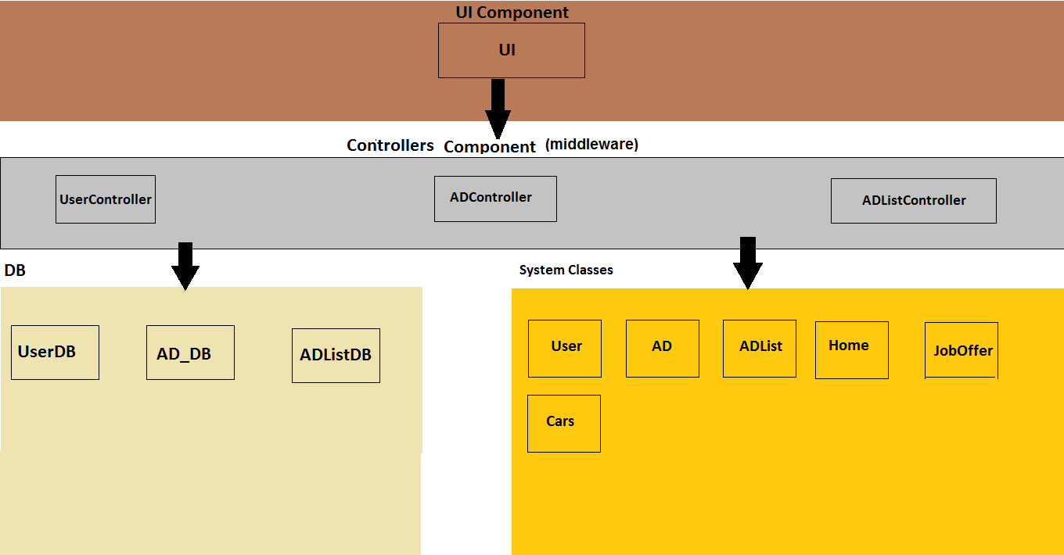

## Class diagrams

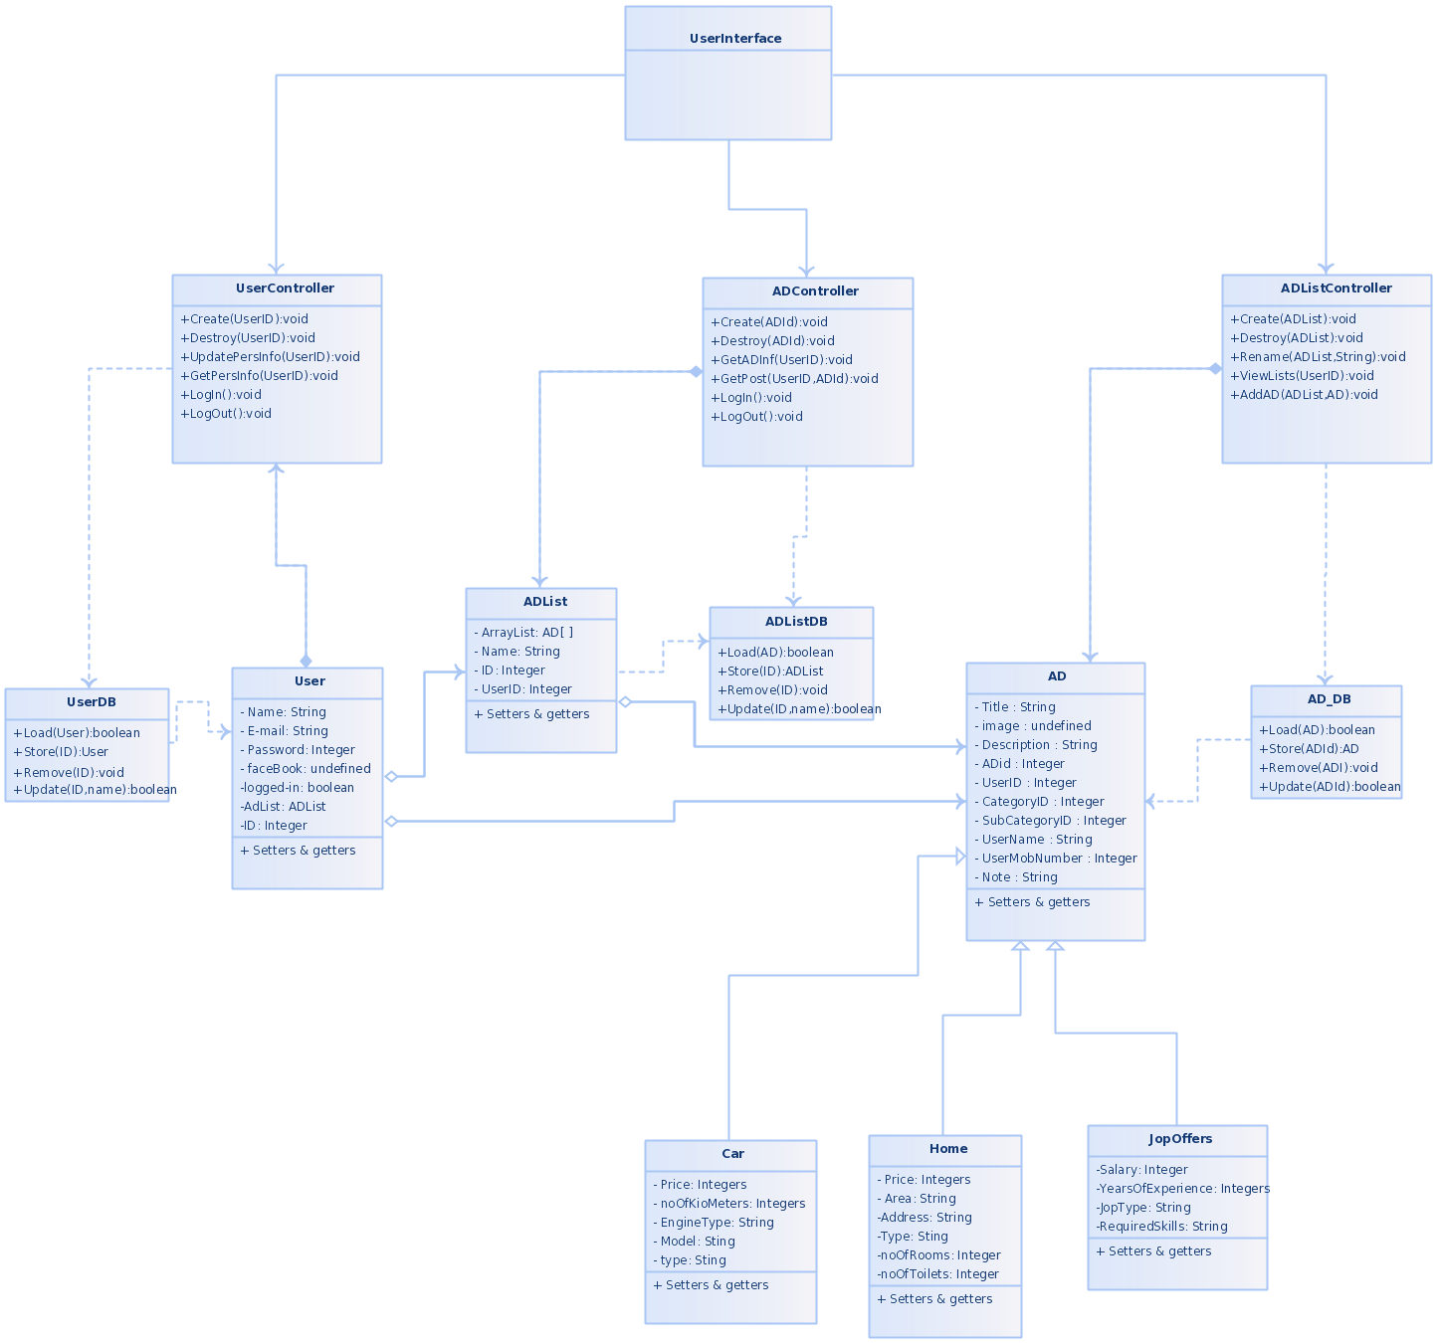

More obvious diagram at: <http://creately.com/diagram/i3c4sco3/bAH2MuGcJBs3rtoaItagtZmf98%3D>

|  |  |  |
| --- | --- | --- |
| Class ID | Class Name | Subsystem ID |
| 1 | userInterface | **Attributes**  +UserObj : UserController  +ADListObj : ADListController  +ADObj : ADController  **Function**  **Connects user to system functions** |
| 2 | userController | **Functions**  +Create(UserID):void  +Destroy(UserID):void  +UpdatePersInfo(UserID):void  +GetPersInfo(UserID):void  +LogIn():void  +LogOut():void |
| 3 | ADListController | **Functions**  +Create(ADList):void  +Destroy(ADList):void  +Rename(ADList,String):void  +ViewLists(UserID):void  +AddAD(ADList,AD):void |
| 4 | ADController | **Functions**  +Create(ADId):void  +Destroy(ADId):void  +GetADInf(UserID):void  +GetPost(UserID,ADId):void |
| 5 | ADList | **Attributes**  - ArrayList: AD[ ]  - Name: String  - ID: Integer  - UserID: Integer  **Functions**  + Setters & getters |
| 6 | ADListDB | **Functions**  +Load(ADList):boolean  +Store(ID):ADList  +Remove(ID):void  +Update(ID,name):boolean |
| 7 | userDB | **Functions**  +Load(User):boolean  +Store(ID):User  +Remove(ID):void  +Update(ID,name):boolean |
| 8 | User | **Attributes**  - Name: String  - E-mail: String  - Password: Integer  - faceBook: undefined  -logged-in: boolean  -AdList: ADList  -ID: Integer  **Functions**  + Setters & getters |
| 9 | AD | **Attributes**  - Title : String  - image : undefined  - Description : String  - ADid : Integer  - UserID : Integer  - CategoryID : Integer  - SubCategoryID : Integer  - UserName : String  - UserMobNumber : Integer  - Note : String  **Functions**  + Setters & getters |
| 10 | AD_DB | Functions+Load(AD):boolean+Store(ADId):AD+Remove(ADI):void+Update(ADId):boolean |
| 11 | category | Attributes- Name: String- ID: String- Describtion: StringFunctions+ Setters & getters |
| 12 | Car | Attributes- Price: Integers- noOfKioMeters: Integers- EngineType: String-Model: StingFunctions+ Setters & getters |
| 13 | Home | Attributes- Price: Integers- Area: String-Address: String-Type: Sting-noOfRooms: Integer-noOfToilets: IntegerFunctions+ Setters & getters |
| 14 | JopOffers | Attributes-Salary: Integer-YearsOfExperience: Integers-JopType: String-RequiredSkills: StringFunctions+ Setters & getters |
| 15 | Honda | Attributes-CategoryID: IntegerFunctions+ Setters & getters |
| 16 | Class Opel | Attributes- CategoryID: IntegersFunctions+ Setters & getters |
| 17 | Class IT | Attributes-CategoryID: IntegerFunctions+ Setters & getters |
| 18 | Accounting | Attributes-CategoryID: IntegerFunctions+ Setters & getters |
| 19 | Mass communication | Attributes-CategoryID: IntegerFunctions+ Setters & getters |

## 

## Sequence diagrams

# Create an Ad

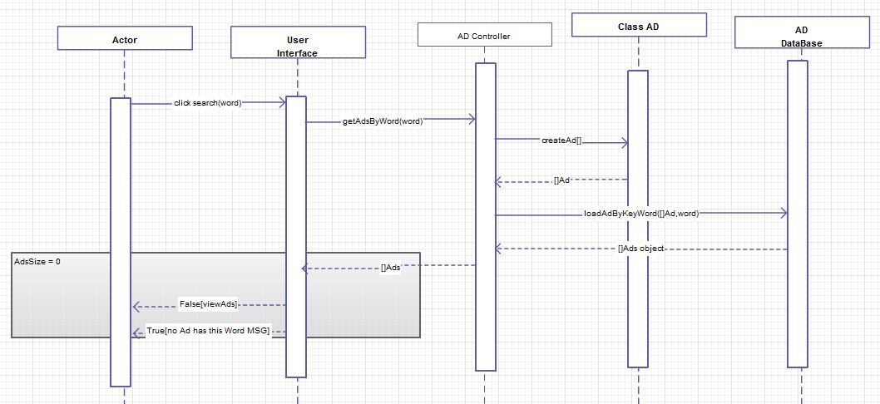Search by key word

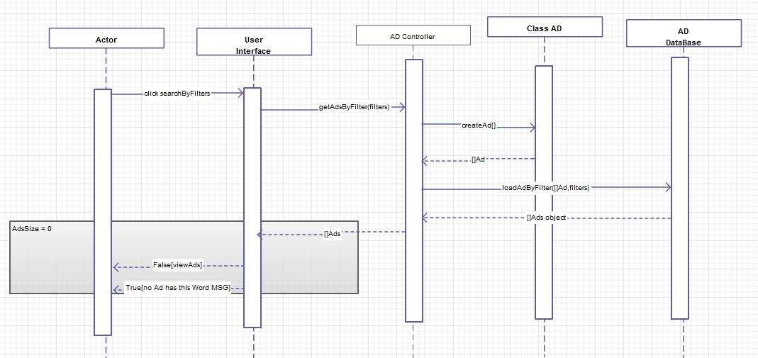Search by Filters

View my Ads

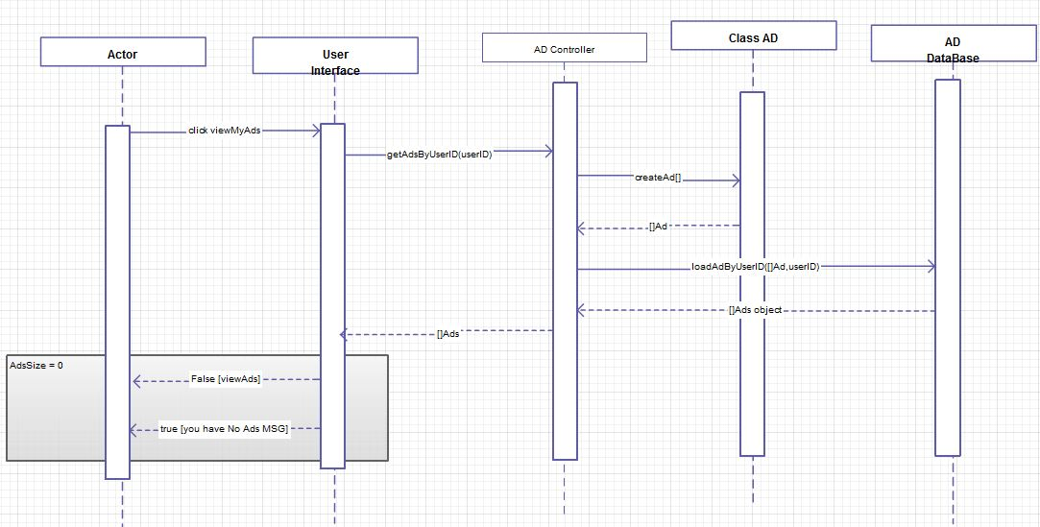The difference between last two functions that the function searchByFilters can be used with many various methods (category – subcategory - place) where we can use each one as single filter or use them mixed together giving more accuracy.

E.g.: 1- search by category, subcategory and place 2- search by place only 3- search by category and place

LoadAdByFilters: search the database for the Ad, identify it and returns array of common Ads depending on the search filters

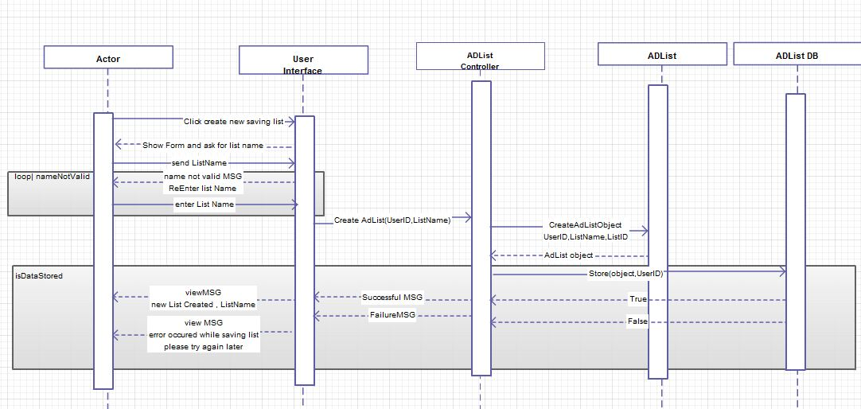Create saving list

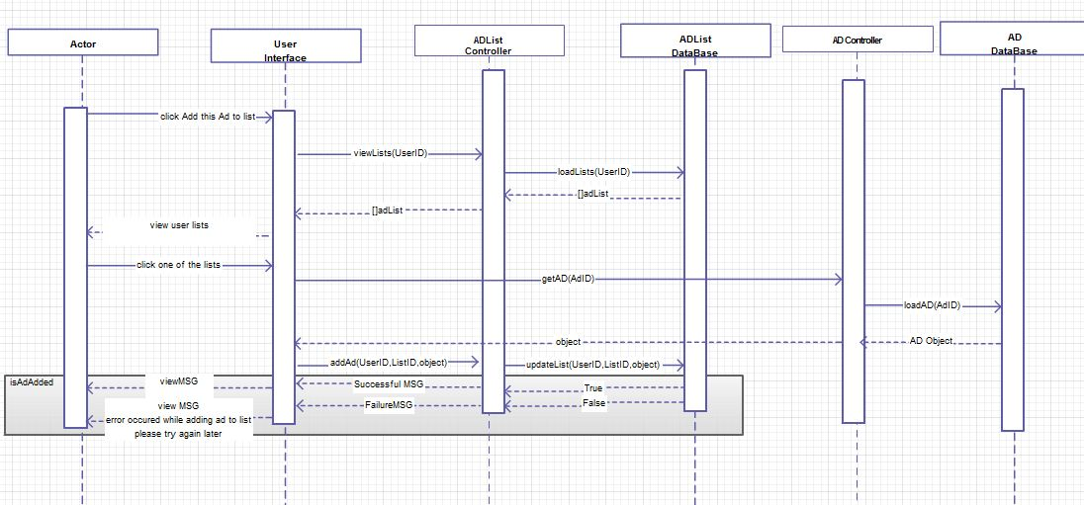Adding Ad to a saving list

## Physical Entity-Relationship Diagram

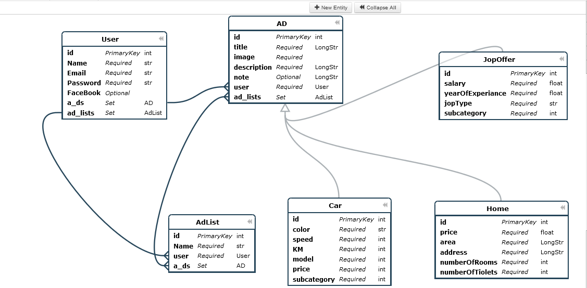

Notice on database diagram

During using the data base we well save the data of each subacategory in its category giving each subcategory an id to easily identifying and using.

E.g.:

Honda subcategory ID: 1

Opel subcategory ID: 2

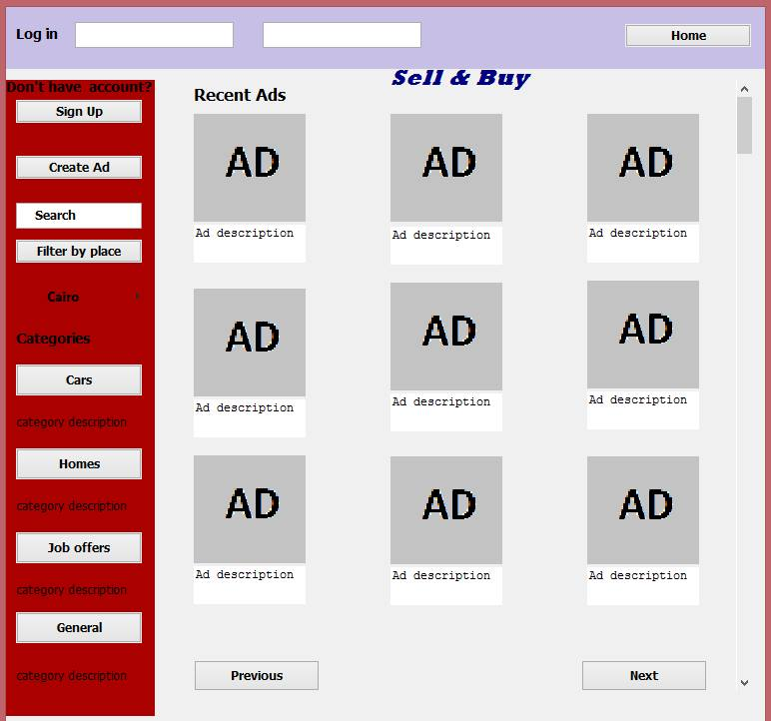**System Screen Shoots:**

# 

# Ownership Report

|  |  |
| --- | --- |
| ***Item*** | **Owners** |
| *System Decomposition* | *Mahmoud Mohamed Hadad* |
| Class diagrams | Ahmed Sayed Eid |
| Sequence diagrams | *Sherif Mohamed Farouk* |
| Physical Entity-Relationship Diagram | *Ahmed Mohamed Fekry* |
| System Screen Shoots | *Mahmoud Mohamed Hadad* |